

THE YENEPOYA INSTITUTE OF ARTS, SCIENCE,
COMMERCE AND MANAGEMENT
Project — Low Level Design
On
Honeypot Network for EdTech Threat Intel

Student Name:
Naveen S Sreedhar
23BCCE125
Table of Contents

1. | Introduction | 3
 | 1.1. Purpose of Document | 3
 | 1.2. Project Executive Summary | 3
 | 1.3. Document Organization | 4
2. | System Overview | 5
3. | Module Design | 5
 | 3.1 Port Listener Module | 5
 | 3.2 Connection Handler Module | 5
 | 3.3 Logging Module  3.4 Fake Response Module  3.5 Dashboard and Monitoring Module | 5  5  6
4. | Data Flow Design | 6
5. | Database Design | 8
 | 5.1 Connection Log Table | 8
 | 5.2 Port Activity Table | 8
 | 5.3 Alert Table | 8
6. | User Interface Design | 9
7. | Security Implementation | 11
8. | Testing and Validation | 11
9. | Project References | 11
10. | Glossary | 11
11.  12. | Front-end  Back-end | 12  12

1. Introduction

1.1. Purpose of Document
This document provides a detailed low-level design of a Honeypot Network system tailored for the Education sector. The goal is to design a system that listens on multiple EdTech-themed ports, logs every connection attempt, and provides real-time threat intelligence through a web-based dashboard. The system focuses on demonstrating how servers listen for connections, how unauthorized access is detected, and how logging works in a cybersecurity context.

Scope:
The system covers:
- Multi-port honeypot listener system
- Connection logging with IP address, port, and timestamp
- Fake EdTech student portal banner response to attackers
- Real-time web dashboard for threat visualization
- JSON-based log storage for audit purposes

In Scope:
- Port listener on ports 8080, 21, 443, 3306
- Attacker IP and timestamp logging
- Fake 'Access Denied' EdTech student portal banner
- Flask-based web dashboard
- Attack statistics and charts

Out of Scope:
- Real network intrusion prevention system
- Deep packet inspection
- Integration with external SIEM tools
- Cloud deployment and public IP configuration

1.2 Project Executive Summary
Modern educational institutions face constant threats from unauthorized access attempts and port scanning attacks. Deploying honeypots is a proven method to detect, log, and analyze these threats before they reach real systems.
This project introduces a structured honeypot system that:
- Listens on multiple EdTech-themed ports simultaneously using Python threading
- Logs every connection attempt with IP address, port, service name, and timestamp

- Sends a fake EdTech student portal banner to deceive and study attacker behaviour
- Stores all logs in a JSON file for persistent record keeping
- Displays real-time attack data on a web dashboard with charts and tables

The system is implemented using:
- Core Listener: Python, Socket Library, Threading
- Dashboard: Flask (Python Framework)
- Storage: JSON File (honeypot_log.json)
- Frontend: HTML, CSS, JavaScript, Chart.js

This solution demonstrates how honeypots work in an EdTech context and provides a working threat intelligence dashboard.

1.3 Document Organization

The document is structured into:

1. Introduction

2. System Overview

3. Module Design

4. Data Flow

5. Database Structure

6. Interface Design

Operational Constraints:

Designed for academic/demo purposes

Local network testing only — no public IP deployment

Requires Python 3.x and Flask to be installed

2. System Overview
The system is designed using a multi-threaded socket-based architecture:
- Attackers interact directly with open ports on the honeypot server
- Python socket listener captures and processes each connection
- All connection data is logged to a persistent JSON file
- Flask dashboard reads log data and presents it visually in real time

The system ensures that every connection attempt is recorded before sending a fake response, making it completely transparent to the defender while appearing as a real EdTech server to the attacker.

3. Module Design
3.1. Port Listener Module
- Binds to multiple ports simultaneously using Python threading
- Listens on ports 8080 (Student Portal), 21 (FTP Server), 443 (HTTPS LMS), 3306 (MySQL Database)
- Accepts incoming TCP connections continuously
3.2. Connection Handler Module
- Extracts attacker IP address and exact connection timestamp
- Identifies which service and port was targeted
- Passes connection data to the logger and fake response modules
3.3. Logging Module
- Saves all connection details to logs/honeypot_log.json
- Records IP address, port number, service name, and timestamp per entry
- Appends new entries without overwriting existing records
3.4. Fake Response Module
- Sends a realistic fake EdTech student portal banner to the attacker
- Banner includes 'EdTech Student Portal — SECURE LOGIN SERVER' and 'ACCESS DENIED' message

- Closes the connection immediately after sending the banner
3.5. Dashboard and Monitoring Module
- Flask web server reads the log file and exposes REST API endpoints
- Displays total hits, unique IPs, active ports, and most targeted port
Shows attack timeline chart, top attacker IPs list, and live connection log table

4. Data Flow Design

i. Attacker initiates TCP connection to a honeypot port

ii. Port listener accepts the connection

iii. Connection handler extracts IP, port, and timestamp

iv. Logger saves the entry to honeypot_log.json

v. Fake response module sends EdTech student portal banner to attacker

vi. Connection is closed

vii. Dashboard reads log file and updates statistics every 5 seconds

viii. Admin views real-time attack data on web dashboard

System Data Flow Diagram:

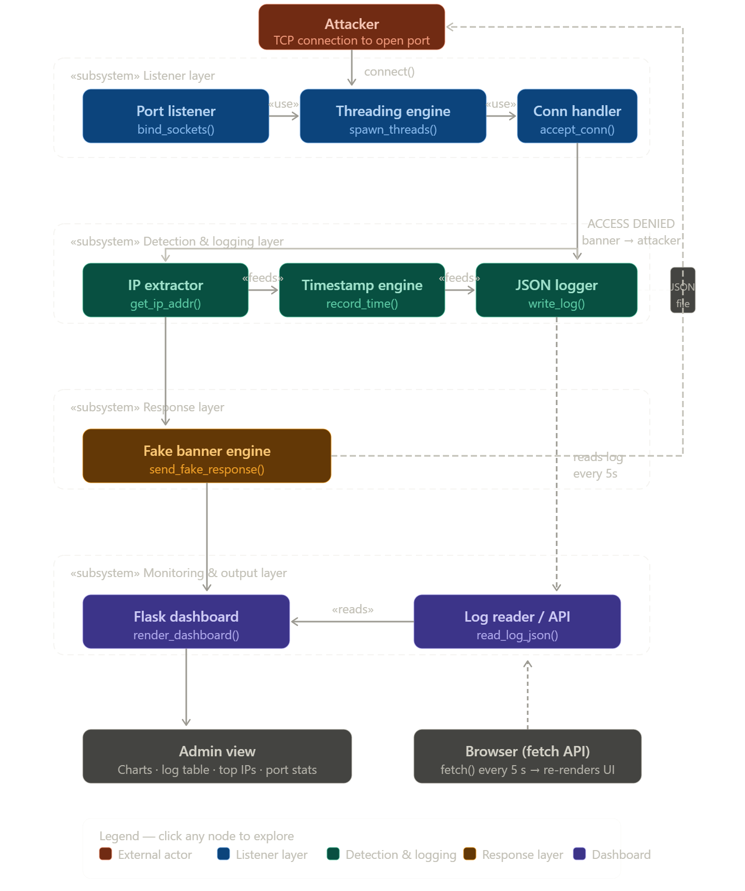

5. Database Design
Storage Used: JSON File (honeypot_log.json)

Tables Used
5.1 Connection Log Table
Field | Data Type | Description
ip | String | Attacker IP address
port | Integer | Targeted port number
service | String | Service name for the port
timestamp | String | Date and time of the connection

5.2 Port Activity Table
Field | Data Type | Description
port_number | Integer | Honeypot port number
service_name | String | Service name label
hit_count | Integer | Total connections received

5.3 Alert Table
Field | Data Type | Description
alert_id | Integer | Unique alert identifier
ip_address | String | IP address that triggered the alert
frequency | Integer | Number of attempts from this IP
last_seen | String | Timestamp of last observed connection

6. User Interface Design

The system includes:

Honeypot Monitoring Dashboard Page

Live Connection Log Table

Attack Timeline Chart

Top Attacker IPs Panel

Port Service Statistics

The interface is designed with a dark cybersecurity theme for professional EdTech threat monitoring

Dashboard Layout Diagram

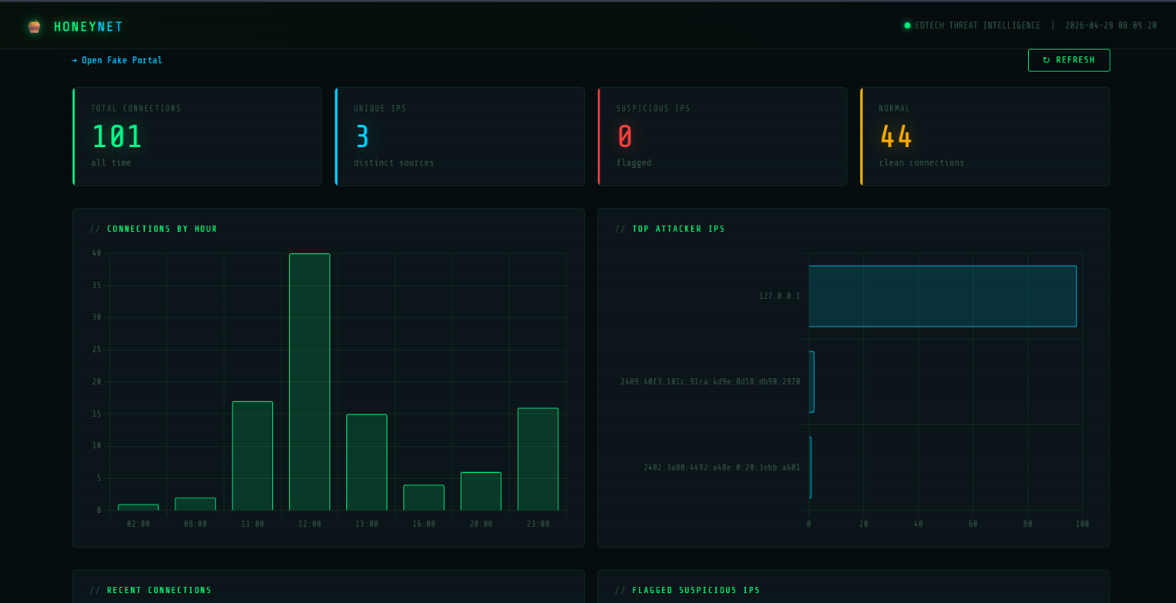

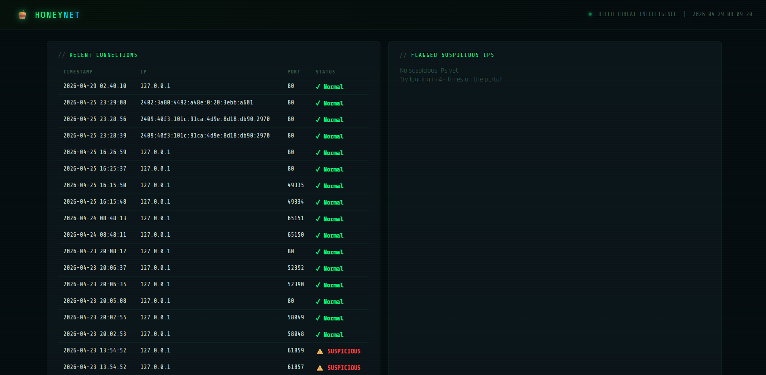

7. Security Implementation
- Fake banner hides all real server information from attackers
- Log file stored locally and not exposed to any external interface
- Dashboard accessible only on localhost (127.0.0.1)
- All ports send identical fake responses to prevent fingerprinting
- Threading ensures one attacker cannot block others from being logged

8. . Testing and Validation
- Functional testing of port listener on all four ports
- Connection logging validation using Test-NetConnection and curl
- Dashboard data accuracy testing against log file
- Basic security testing — fake banner content verification

9. Project References
- Python Socket Library Official Documentation
- Flask Official Documentation
- OWASP Honeypot Project Guidelines
- VS Code IDE
- Chart.js Documentation — https://www.chartjs.org/docs

10. Glossary
- Honeypot: A security trap set to detect unauthorized access attempts

- Port: A communication endpoint number on a server
- Socket: Low-level Python network communication interface
- Threading: Running multiple listener tasks simultaneously
- Flask: Python web framework used for the dashboard
- Threat Intel: Information collected about cyber attack attempts
- LMS: Learning Management System — an EdTech platform

11. FRONT-END

The EduNova fake EdTech portal serves as the primary honeypot bait. It is a fully responsive HTML5/CSS3 website designed to look exactly like a legitimate student learning platform. When an attacker submits the login form, their credentials are silently captured by the Python Flask backend.
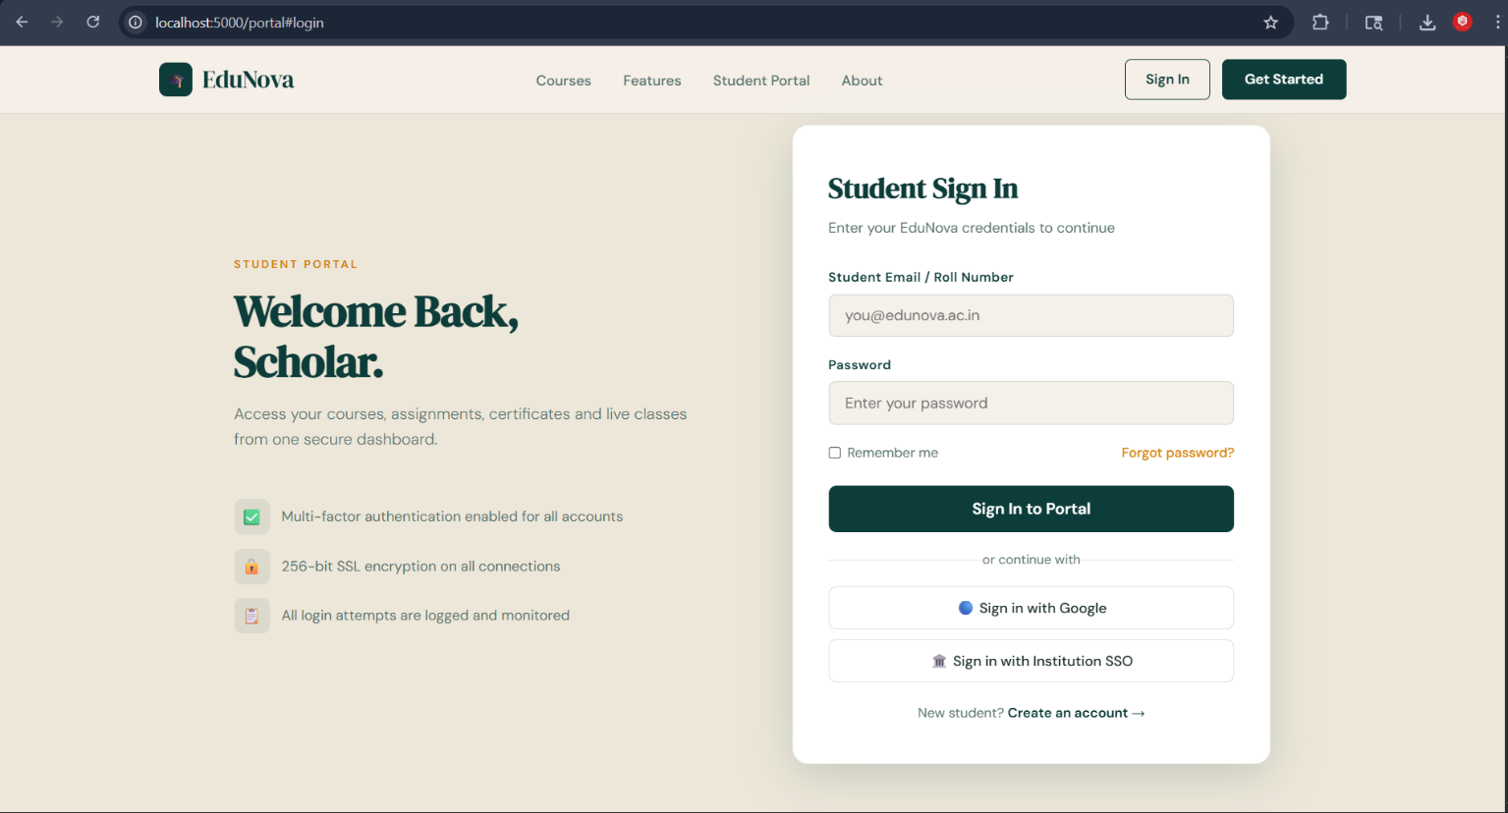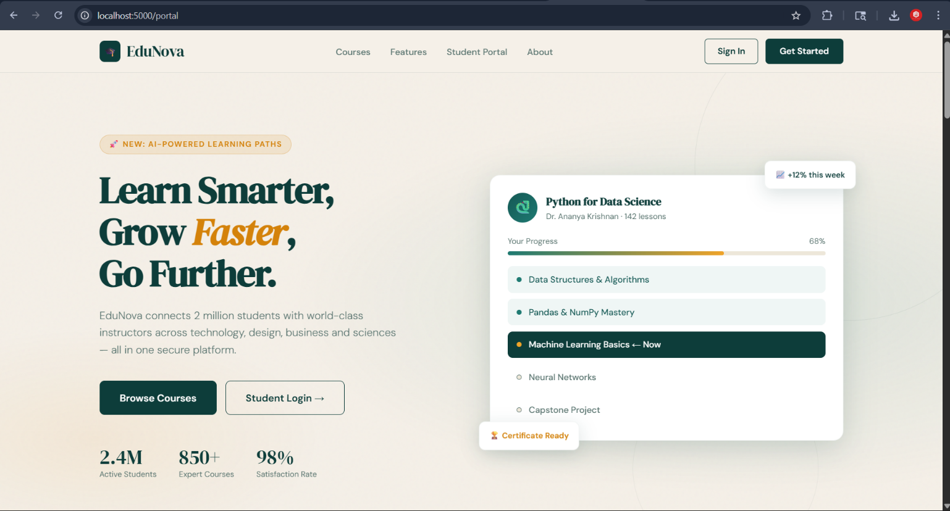

FRONT-END (continued)
When a login attempt is made, the attacker is shown a realistic 'Access Denied' page. Meanwhile, the honeypot has already silently logged their IP address, email, and password to the CSV file.

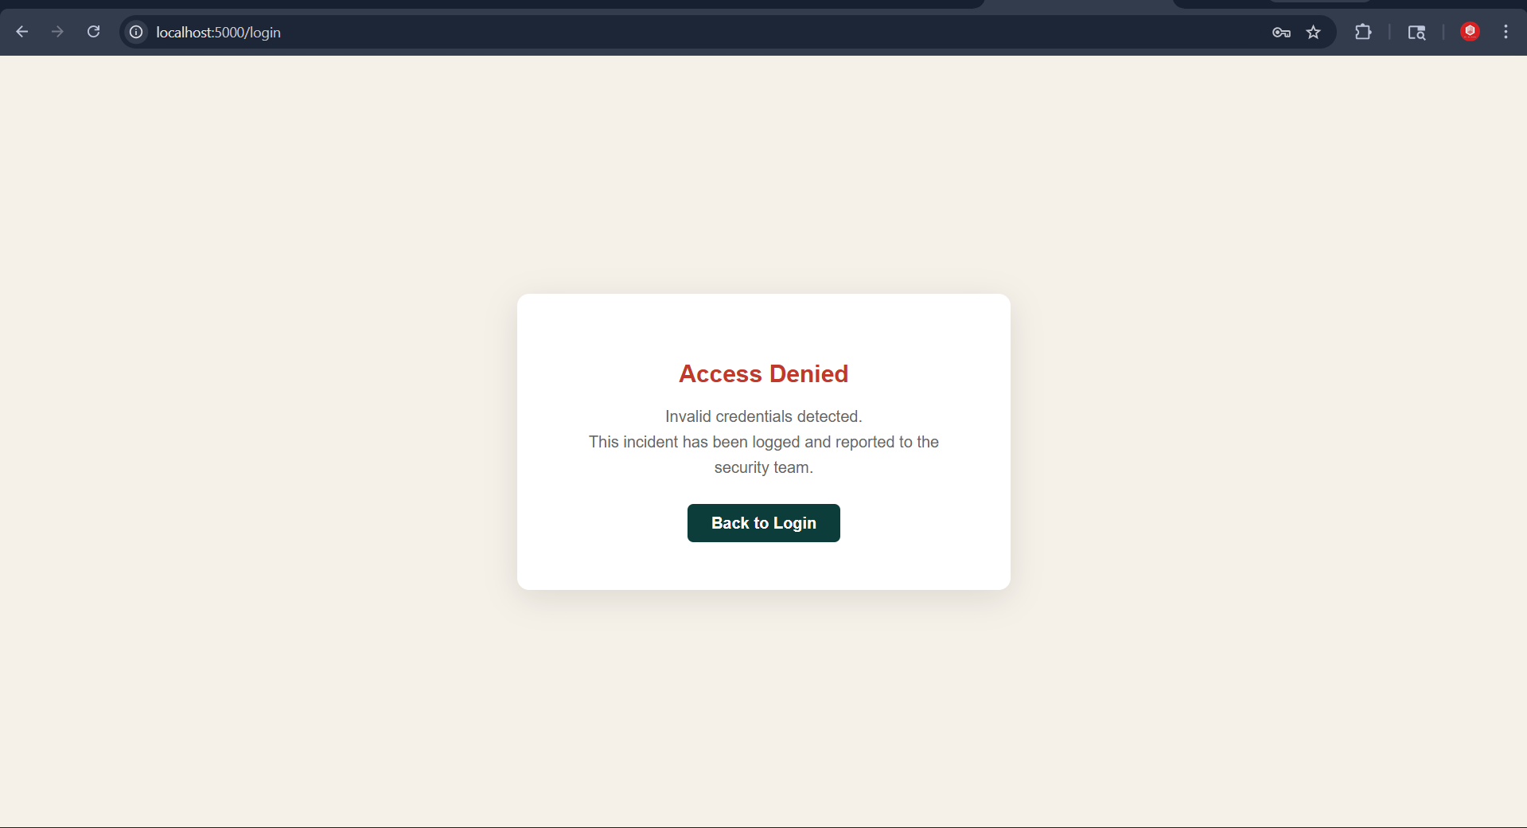

The threat intelligence dashboard displays all captured attack data in real time. It uses Chart.js for visualizations and is styled with a dark cybersecurity aesthetic.
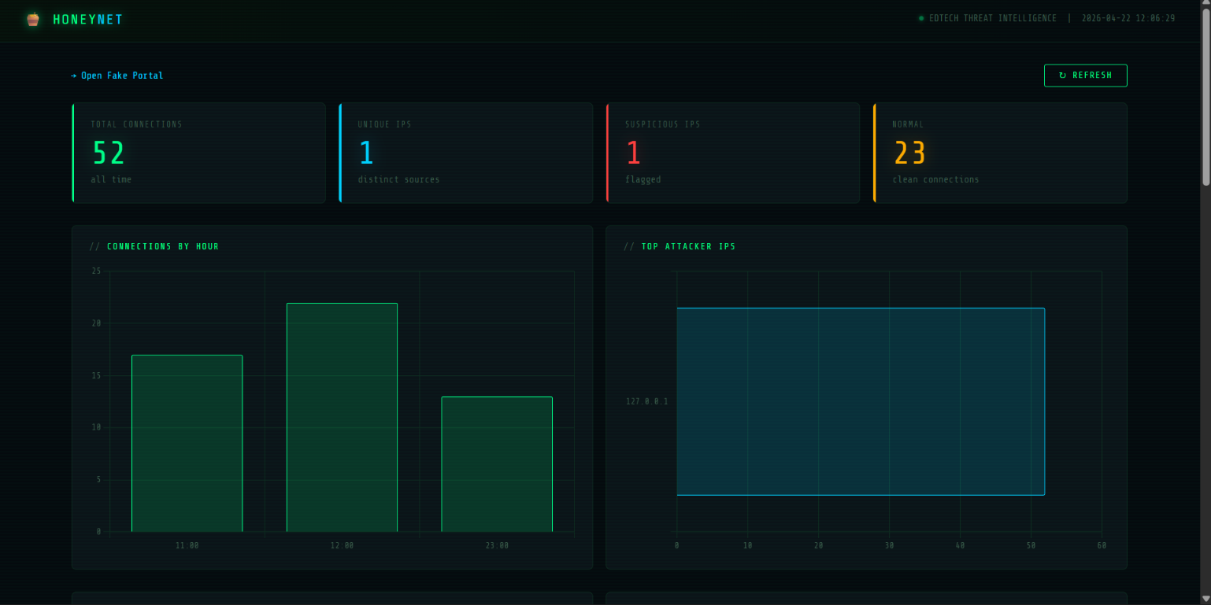

12. BACK-END – PYTHON
The backend is written entirely in Python. The core honeypot server (honeypot.py) uses socket programming and threading. All project files are visible in the VS Code Explorer panel on the left side. The code is cleanly structured across 6 modules
The handle_client() function processes each connection in its own thread. It detects suspicious IPs, logs data, sends the fake response, and closes the connection. Error handling silently ignores normal browser disconnect behavior
The start_honeypot() function is the main entry point. It sets up the TCP socket server, binds to port 8888, and runs an infinite accept loop. Each new connection spawns a dedicated daemon thread

